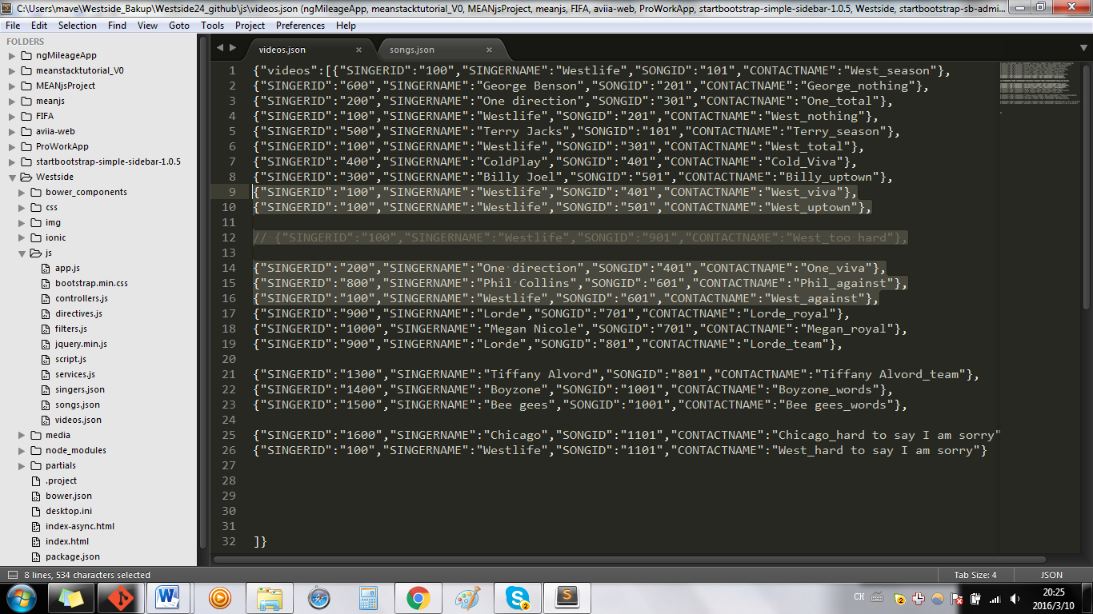

{"SINGERID":"100","SINGERNAME":"Westlife","SONGID":"401","CONTACTNAME":"West_viva"},

{"SINGERID":"100","SINGERNAME":"Westlife","SONGID":"501","CONTACTNAME":"West_uptown"},

// {"SINGERID":"100","SINGERNAME":"Westlife","SONGID":"901","CONTACTNAME":"West_too hard"},

{"SINGERID":"200","SINGERNAME":"One direction","SONGID":"401","CONTACTNAME":"One_viva"},

{"SINGERID":"800","SINGERNAME":"Phil Collins","SONGID":"601","CONTACTNAME":"Phil_against"},

{"SINGERID":"100","SINGERNAME":"Westlife","SONGID":"601","CONTACTNAME":"West_against"},

**// Comment: CanNOT delete a record like the above for a JSON file.**

**Must REMOVE it, instead of COMMENT it.**